RBR Pacenote Plugin

Quick Start Guide

Table of Contents
Software Installation. 3
First time running. 3
Editing Existing Notes 4
Adding Notes 5
Deleting Notes 6
Call Distances 6
Pacenote Callout Timing 7
Camera Editor 8
Car Damage Indicator 10

Software Installation.
This quick start guide assumes that you have installed the Plugin as described in the readme files that came with the Plugin.

First time running.
It’s suggested that you make a replay of the stage you wish to edit pacenotes in first – do this at a slow to medium pace staying in the middle of the road.
Using a replay for editing pacenotes saves you from having to drive and control the car all the time by yourself and having to slow down for editing.
A hint for RSRBR users: Once you have the replay available, open this in RSCenter using RBR SSE from the User Profile in the main menu.
Once the stage starts double click on the left-hand mouse button and
the pacenote window will popup onto the screen. Pause the stage by using
the pause button on the right-hand side of the pacenote window just below the menu bar.

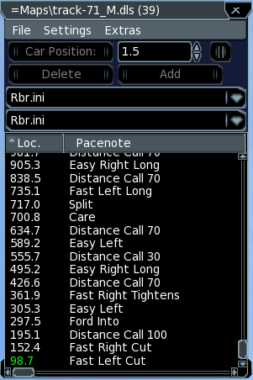

Depending on which installation of the pacenote type (i.e. Descriptive, Numeric Ascending, or Numeric Descending) you should choose the following combinations from the dropdown combo boxes below the Location button.
The upper combobox contains the pacenotes ini file.

Rbr.ini - Uses only the standard pacenotes built into RBR and the original sounds. Some calls, e.g. Cut, Don't Cut ect., can only be used as modifiers to another
pacenote - usually a corner - call.

Rbr-Enhanced.ini - Uses the standard pacenotes built into RBR and some additional notes supplied by the plugin. For the standard calls the original sounds are being used. Only the Minus and Plus calls require additional sound files, which are shipped
with the original game (except for the english language) and provided by the
plugin. The additional pacenotes include e.g. Callout Time, Callout Distance and allow
for using modifier notes, like Cut and Don't Cut, to be used as normal calls.

All the following pacenotes ini files require a separate sound file for each
note. These configurations only differ in the way corners are called. The
other pacenotes are all the same for every variant.

All these variants offer many additional pacenotes in several categories.

Descriptive.ini - Uses descriptive pacenotes like e.g. Easy Left.

Numeric.ini - Uses numeric, ascending pacenotes for the corner calls, e.g. One Left, Two Left ect., up to Flat Left.

Numeric-Swapped.ini - Uses numeric, swapped ascending pacenotes for the corner calls, e.g. Left One, Left Two ect. up to Left Flat.

Numeric-Descending.ini - Uses numeric, descending pacenotes for the corner calls, e.g. Six Left, Five Left, down to Flat Left.

Numeric-Descending-Swapped.ini - Uses numeric, swapped descending pacenotes for the corner calls, e.g. Left Six, Left Five, down to Left Flat.

The lower combobox contains the ranges ini file.

Rbr.ini - Uses the standard RBR ranges and the built-in, original sounds.

Extended.ini - Uses extended, custom ranges and custom sound files, providing a finer granularity of the range calls.

The names of the ini files chosen in the comboboxes will be saved in the DLS
file of the currently active track when you Save the file via the Save file menu.
The next time you load the stage, the stored ini file will be used to
populate the list and properties windows, respectively.

If you release the pause button the replay will start and drive through the stage reading the notes and scrolling the pacenote window.
You can move forward and backward through the stage by changing the numbers in the box next to the car position and then pressing the car position button.
Alternatively you can use the up and down toggle buttons to the right of the number box and then press the Car Position button.

Editing Existing Notes
Click on the note that you wish to edit in the Pacenote window and the Pacenote Properties window will open on the right-hand side of the screen.

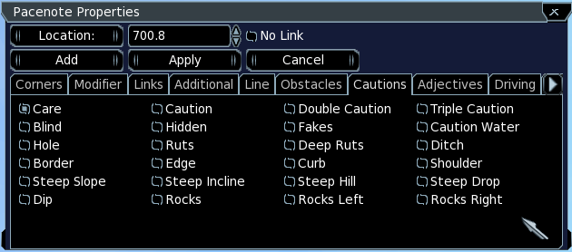
If you wish to change the note for an entirely new note then find the new note that you require in the Pacenote Properties window then click apply. You can change the position of the note by altering the location numbers to the right of the Location: button then clicking apply.

Adding Notes
New notes are added above the existing note that you have highlighted in the Pacenote window. Clicking the add button will open the Pacenote Properties window where you can choose the note you wish to add from one of the various tab that you have in the Pacenote Properties window and then clicking the Apply button on the Pacenote Properties window. By default the pacenote will be added at an interval of .1 ahead of the note that is highlighted in the Pacenote window if however your car is positioned somewhere else on the track, pressing the location button on the Pacenote Properties window will apply the current car's position to the location value in the Pacenote Properties window. That figure will then be the notes position when you hit the apply button.

Deleting Notes
Highlight the note you wish to delete in the Pacenote window then press the delete button. If you are wishing to delete a block of notes then if you start with the furthest one into the stage and delete that, the next note beneath it will be selected and you just keep pressing the delete button until you have deleted all of the group that you wanted.

Call Distances
These are inserted/replaced in exactly the same way that other notes are inserted/replaced. If you use the Add button whilst the previous note is highlighted then the Location shown in the Pacenote Properties window will be .1 in advance of the position of the highlighted note and if you then choose Call Distance from the Properties window and press the Apply button the Call Distance will be added to the Pacenote list with a numeric distance to the next obstacle.

If you do not want the distance call being emitted right after the current
pacenote, you only have to place the notes a little bit differently.

To have the distance calls called as you want them, simply do this:
1. place your corner call as usual at corner entry, e.g. EASYLEFT
2. apply the "No Link" attribute to the EASYLEFT (in order not to call AND/INTO)
3. place an EMPTY_CALL note where you want the distance call to happen
4. place the normal DISTANCE_CALL note right after the EMPTY_CALL (0.1m behind)
or, to be exact, at the appropriate location to get the "right" distance to the next note (i.e. the distance is being calculated from this location to the next)

So you have:

165.4 FLATRIGHT
70.1 DISTANCE_CALL 100
70.0 EMPTY_CALL <-- the actual call happens 20 "meters" after the corner call
50.4 EASYLEFT*

or maybe e.g.

165.4 FLATRIGHT
90.0 DISTANCE_CALL 70
70.0 EMPTY_CALL <-- the actual call happens 20 "meters" after the corner call
50.4 EASYLEFT*

Pacenote Callout Timing
Where you position a pacenote on the track (Stage) dictates where that pacenote is called by RBR. In RBR via the Options Menu >>> Pacenotes >>> Callout Distance you can vary the time that pacenotes are called from their original position. The standard setting in RBR is normally 8 squares = 4 seconds of Callout Distance. This means that all of your pacenotes are called 4 seconds before you reach the point at which you placed the pacenote.

So as your pace improves you may want to increase the Callout Distance to give you extra time to react to the next bend or obstacle. Setting the Stack doesn't matter at all here.

If you get used to doing it that way all the time all original tracks will call the pacenotes as expected.

In certain circumstances you may want to have a specific pacenote called at a different time than the default time of 4 seconds so that the note is called say, at the exact spot that you inserted the note.

To achieve this this you need to nullify the 4 second advance so that the note is called where you placed it on the track. This is done by inserting a Callout Time prior to the note call you wish to move. You have to adjust the time by a negative value to negate the built in value. You will need to test this to be verify the actual callout position.
This would neutralize the settings made in the options (provided that it is 8 squares):

Example:
90.8 hairpin right
80.5 Special Call
55.1 Callout Time -4.0s
55.0 flat right
50.0 flat left

The callout time above temporarily decreases/increases the callout time specified in the options for the immediately following pace note.
Don't make this sticky, otherwise the setting will apply to all subsequent calls.

Same goes with call distance, the only difference that it is specified in meters.
The values are ADDED to the configured values, so you would need to specify a negative value to get a later call (as in the example above).

Camera Editor
The Pacenote Plugin camera is intended only for use within the Pacenote Editor environment. It is not intended to replace the RBR camera or any of the other hacks that are available.

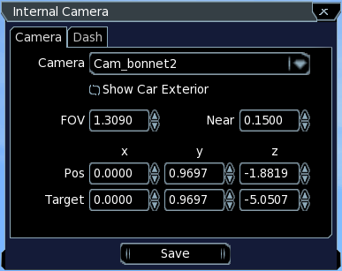
To activate the Camera Editor window, double-click the RIGHT mouse button. The Camera Editor dialog will only be visible if the current RBR camera mode is one of the internal cameras cam_bonnet, cam_bonnet2 or cam_internal. All other cameras (external, replay) are not editable hence the dialog is not shown.
The camera window has two tabs. The first enables you to change the camera, the second allows for changing the positions of the minidash and the digidash (=full dash), respectively.

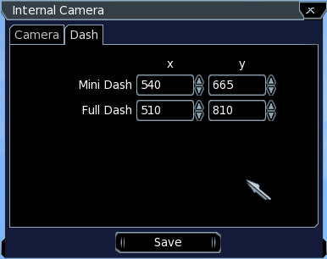

You can change the current camera by choosing an entry in the Camera combo box. To edit the geometry values you use the up/down arrows of the spinner controls or enter a value directly. Once you have the best setting for yourself then save the setting using the Save button at the bottom of the screen.

The values represent the corresponding keys in the camera ini file. The values of the car specific camera settings are being saved to the ini file of the current car. The custom camera geometry values are being saved to the Cameras.ini file located in the Pacenote Plugins folder.

If you are wanting to accurately place notes on a track then you might want to switch to the helicopter camera. This view will allow you to stop the car on the corner and see what the severity of the bend is, this will mean that you get the corner call quite accurate first time.

The Dash tab lets you change the position of both dashes. The „Save“ button saves the positions to a separate ini file located in the Pacenote Plugins folder. The positions are restored if you restart RBR.

Car Damage Indicator
The Car Damage Indicator window can be activated by selecting the corresponding menu item in the Extras menu of the Pacenote List dialog.

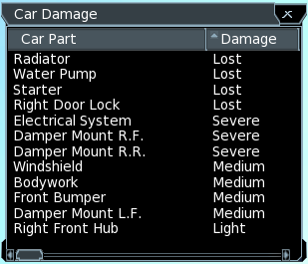

The Car Damage window shows the damaged parts in alphabetical order along with the damage suffered. Click on the column header to sort by that column.

